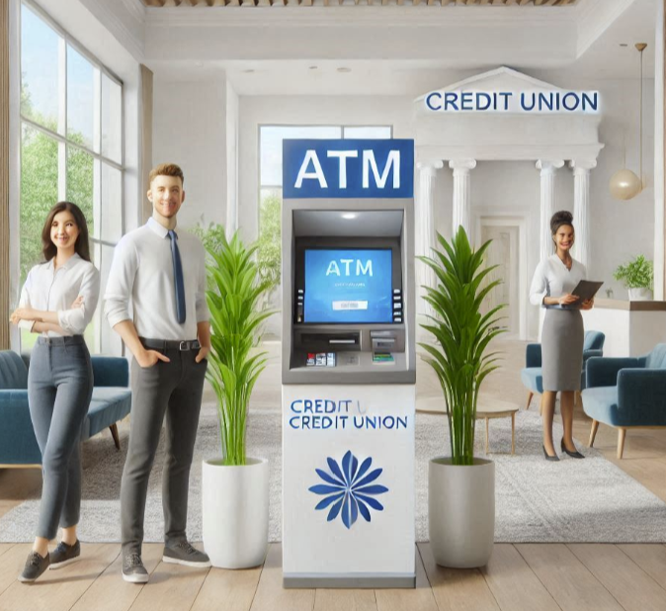

An Automated Teller Machine (ATM) lets you bank without stepping into a branch. You can withdraw cash, deposit money, transfer funds, and check balances—all without the wait! ATMs are found in shopping centers and gas stations, giving convenient access to your money anytime, anywhere.

**Why Are ATMs Important?**

* **24/7 Access**: ATMs are available any time of day or night, so you don’t have to wait for business hours to access your money.
* **Convenience**: With thousands of ATMs worldwide, you can access your funds almost anywhere.
* **Speed**: ATMs let you complete basic transactions quickly, saving you time.
* **Privacy**: ATMs allow you to conduct banking activities privately without speaking to a teller.

**What Can You Do at an ATM?**

While ATMs are best known for withdrawing cash, they can do much more. Depending on the machine, you can:

* Withdraw cash
* Deposit checks and cash
* Transfer money between your accounts
* Check your balance
* Pay bills (in some locations)
* Update your contact information (in select ATMs)

**Benefits of Using an ATM**

* Immediate access to cash
* Avoiding teller lines
* No branch visits are needed
* Avoid fees by using an ATM within your credit union’s network to avoid fees.

Where can you find an ATM? Check out CU Station™, where we help locate credit unions offering ATMs. Find your nearest ATM and enjoy the convenience of banking on your terms. <sign up>